Used for comparison :

filters=64,

kernel_size=3,

Stride=1,

activation='relu'

Padding = ‘same’

Filters - 64

Kernel_size - 3

Strides - 1

Padding - ‘same’ if the size id fine

Activation - ‘relu’

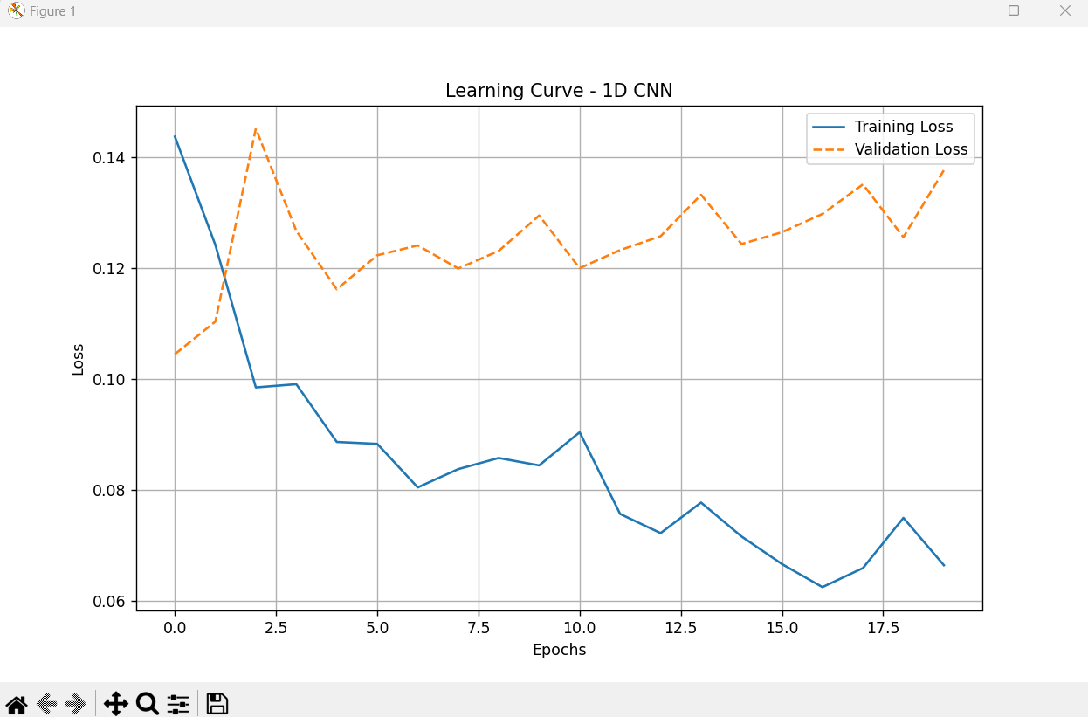

 filters=64,

    kernel_size=3,

    strides=1,

    padding='same',

    activation='tanh'

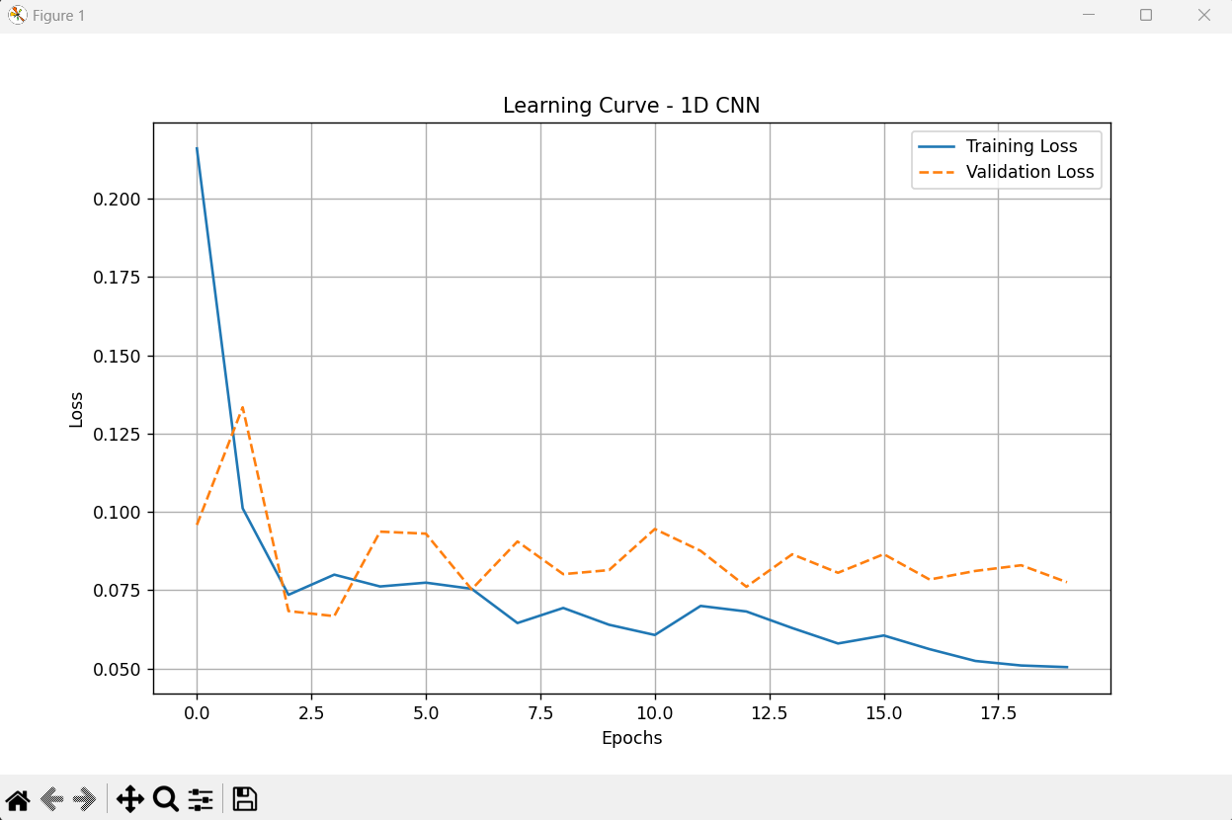

filters=32,

    kernel_size=3,

    strides=1,

    padding='same',

    activation='tanh'

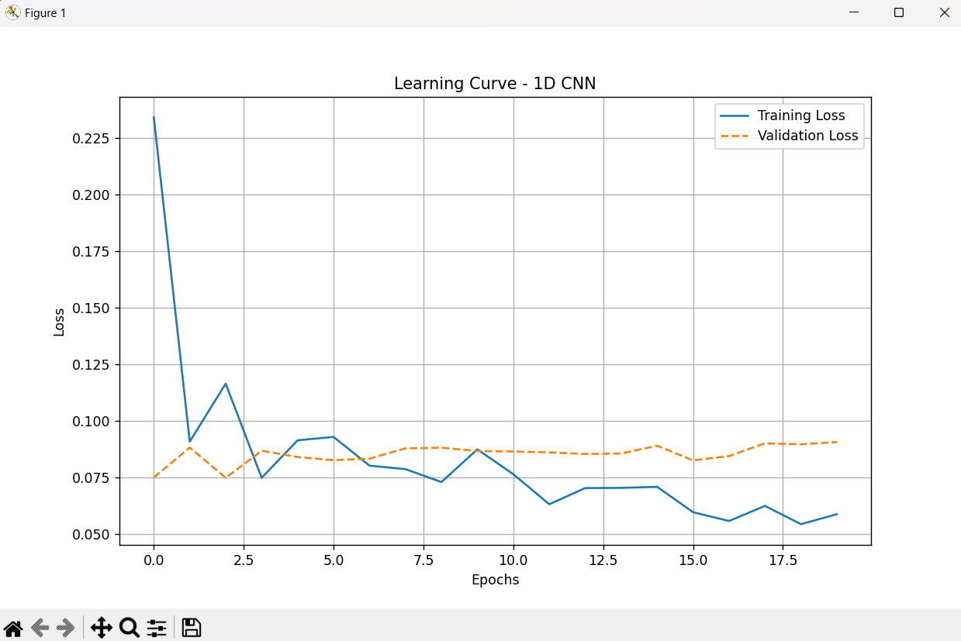

filters=32,

    kernel_size=6,

    strides=1,

    padding='same',

    activation='tanh'

